Design Spec of registration VFS

Purpose:

To automatically register VSF appointment in specific Visa Application Centre.

Function Design:

1. Create table to Store the requirements of registration

|  |  |
| --- | --- |
| Field name | Value |
| Email | Email for login |
| Password | Password for login |
| Register Name | registerName key of table |
| Target Centre | Can be list comma splited  Shanghai,Guangzhou,Beijing  Using this list to try get appointment |
| Target date | The ealiest target date |
| Next try time | Store the automatically next try time  If =9999/1/1 then won’t start . |
| Success | True= success  False=not success  Default False |
| Send email | True=success email sent  False =no email sent |
|  |  |

1. Use Python function to login and simulate operation try to get the appointment

This is the fail page

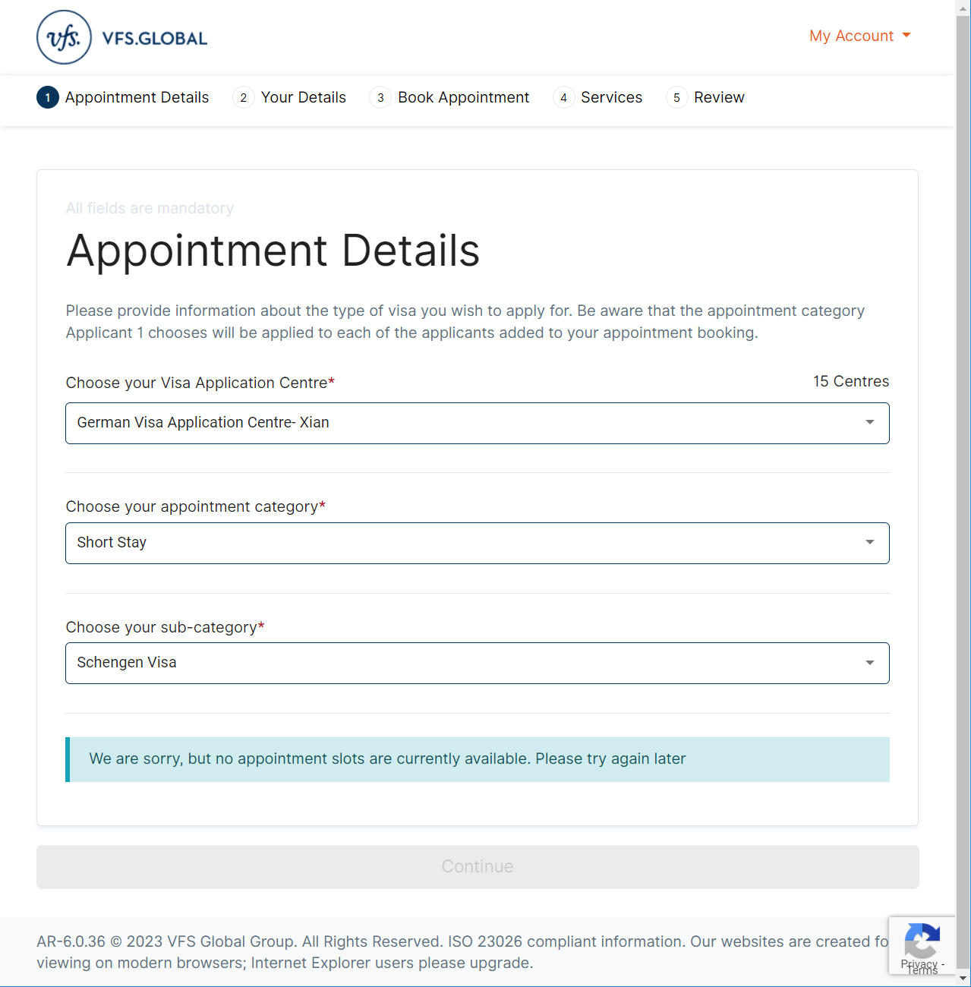

1. When Continue button is enabled , means can go to next steps

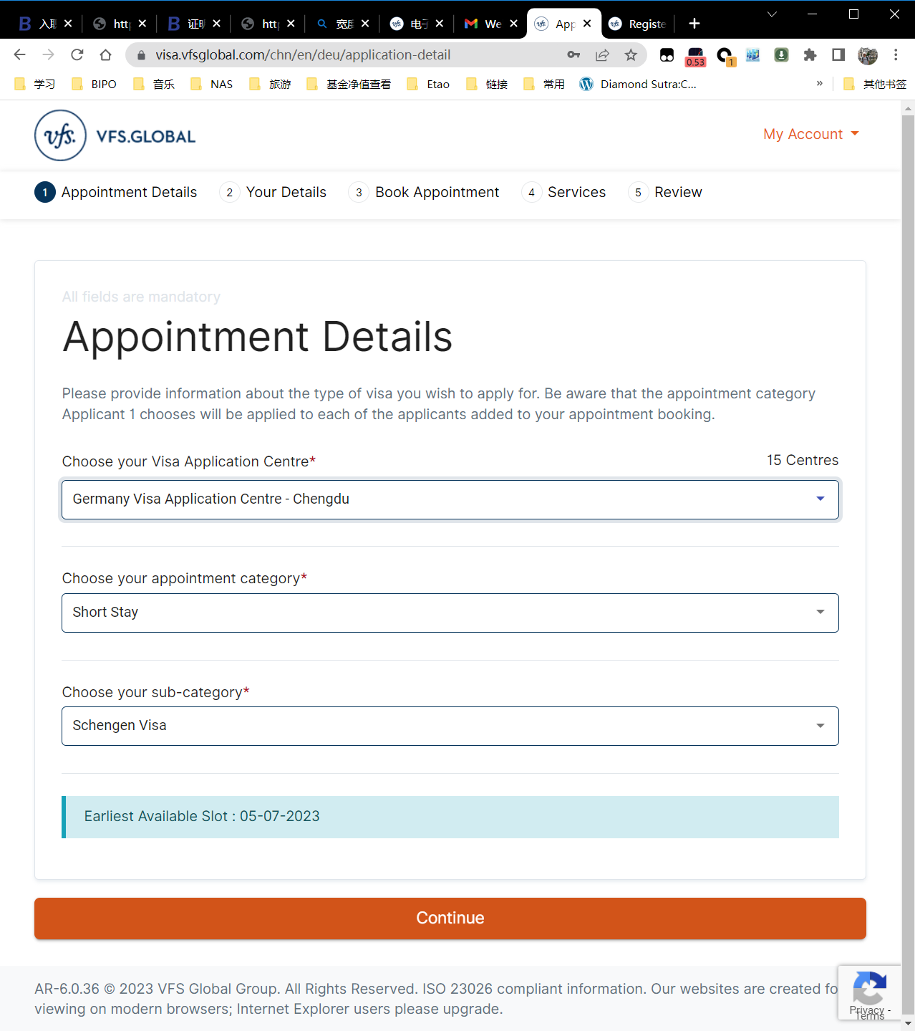

1. Fill the detail information with the following table

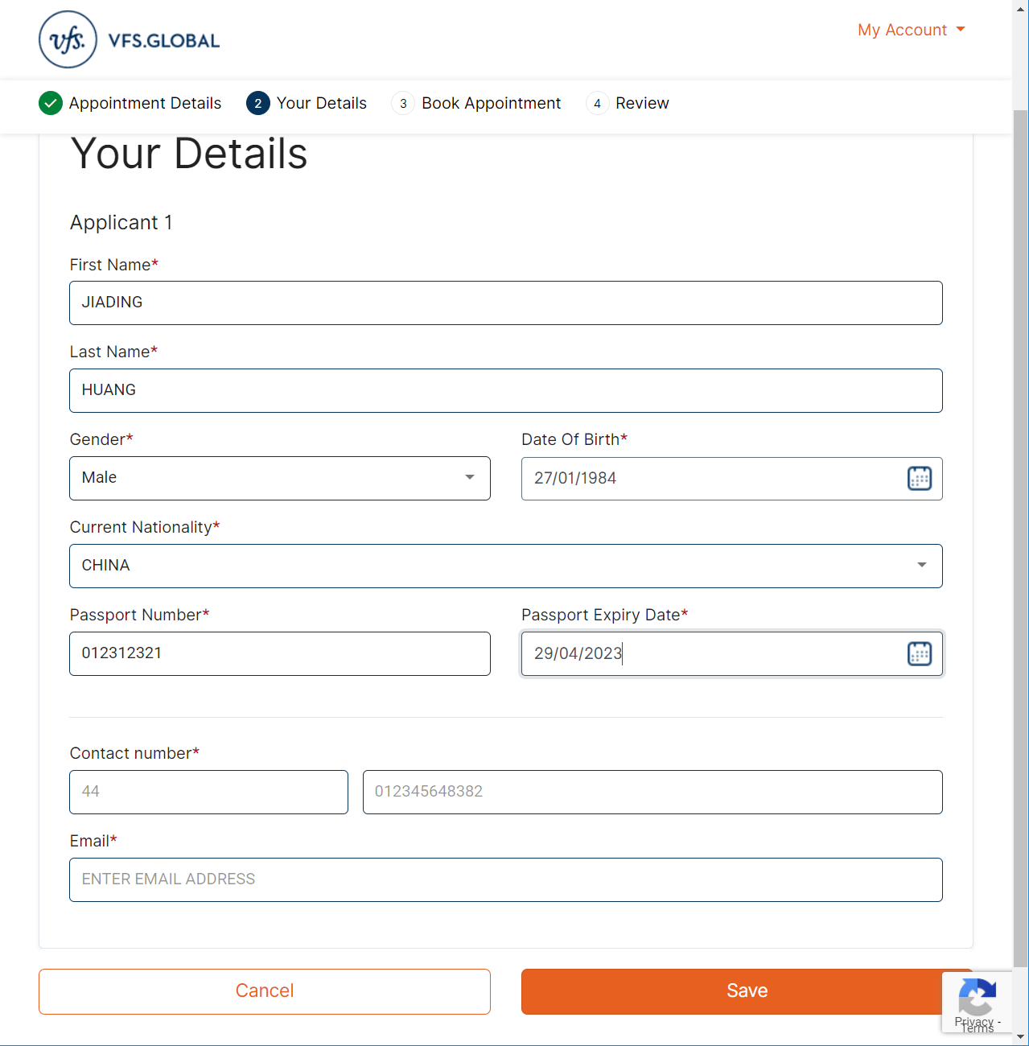



CAN ADD another applicant

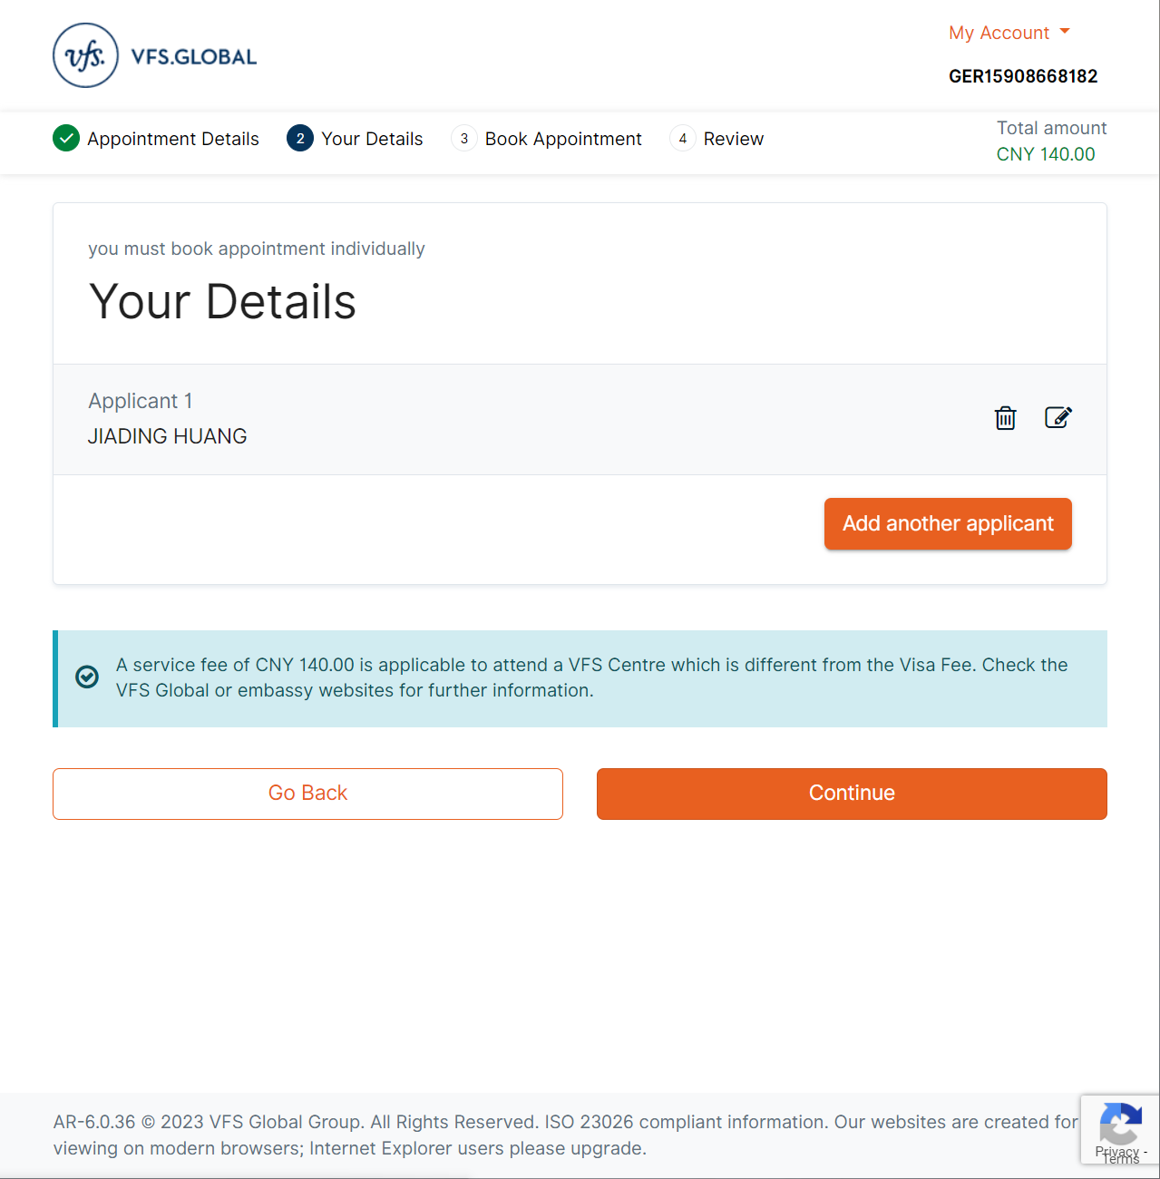

OTP to Email

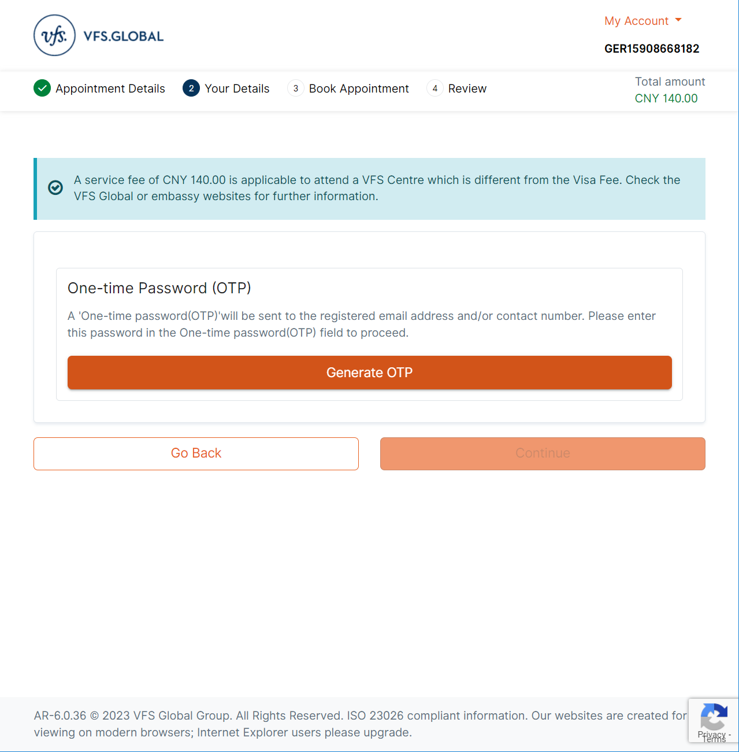

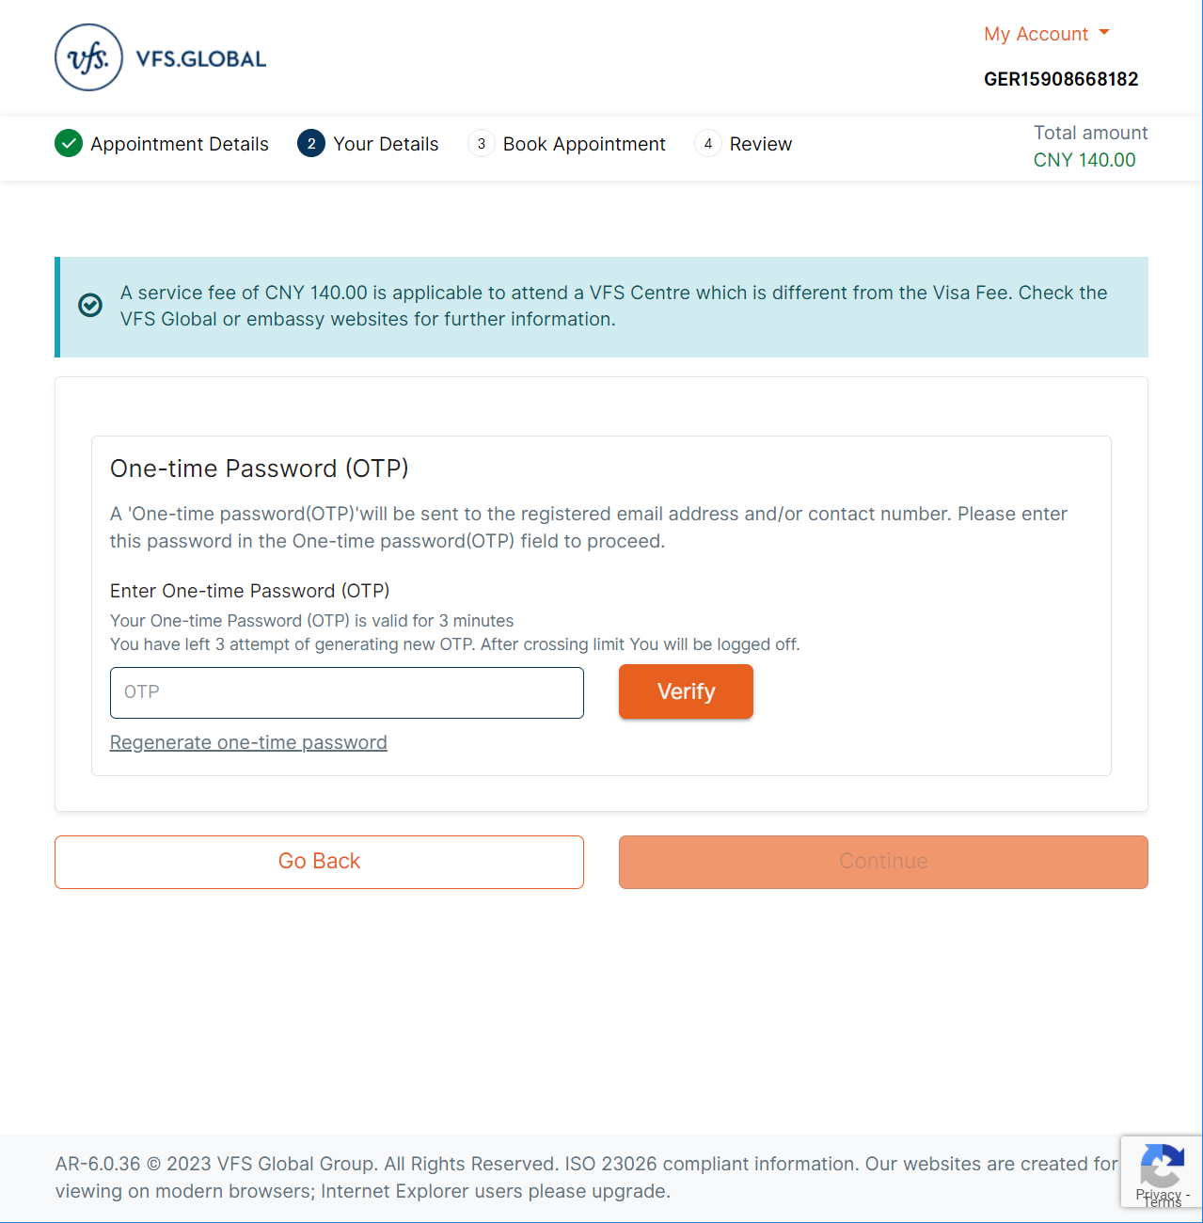

OTP email

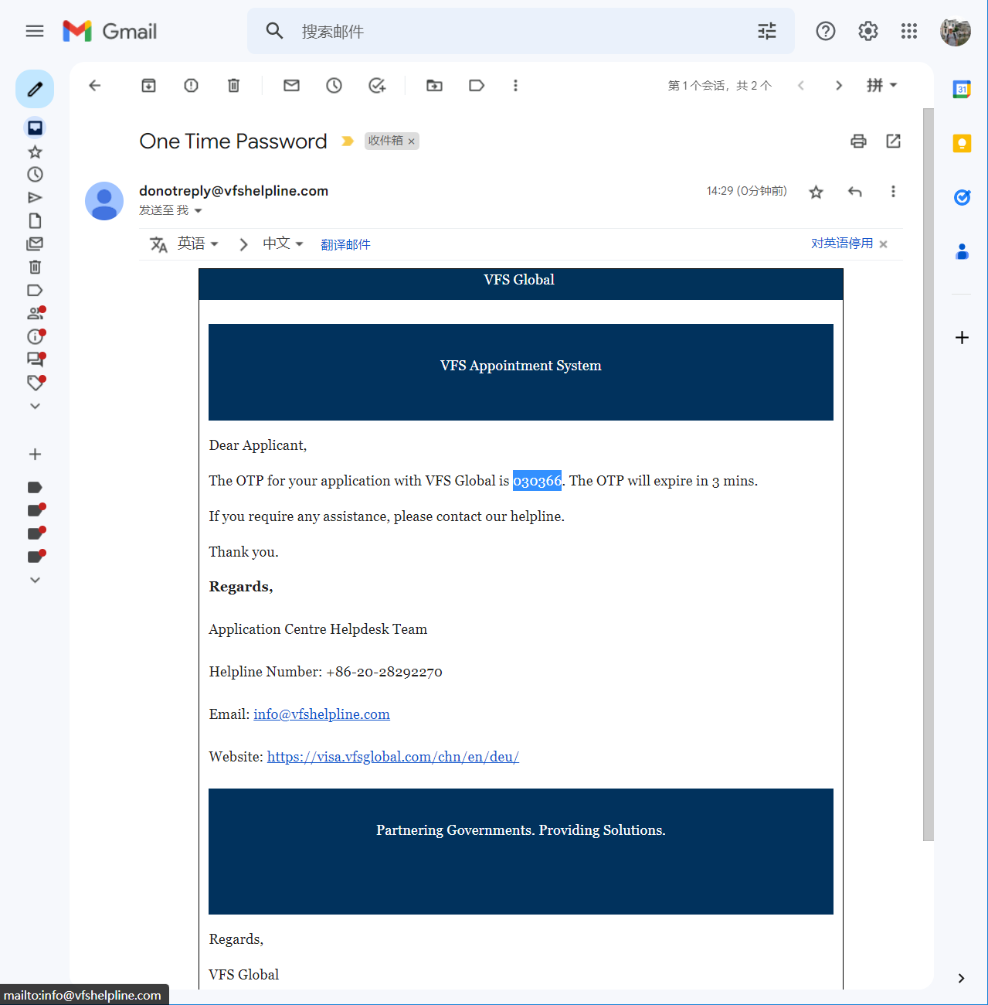

OTP success > continue

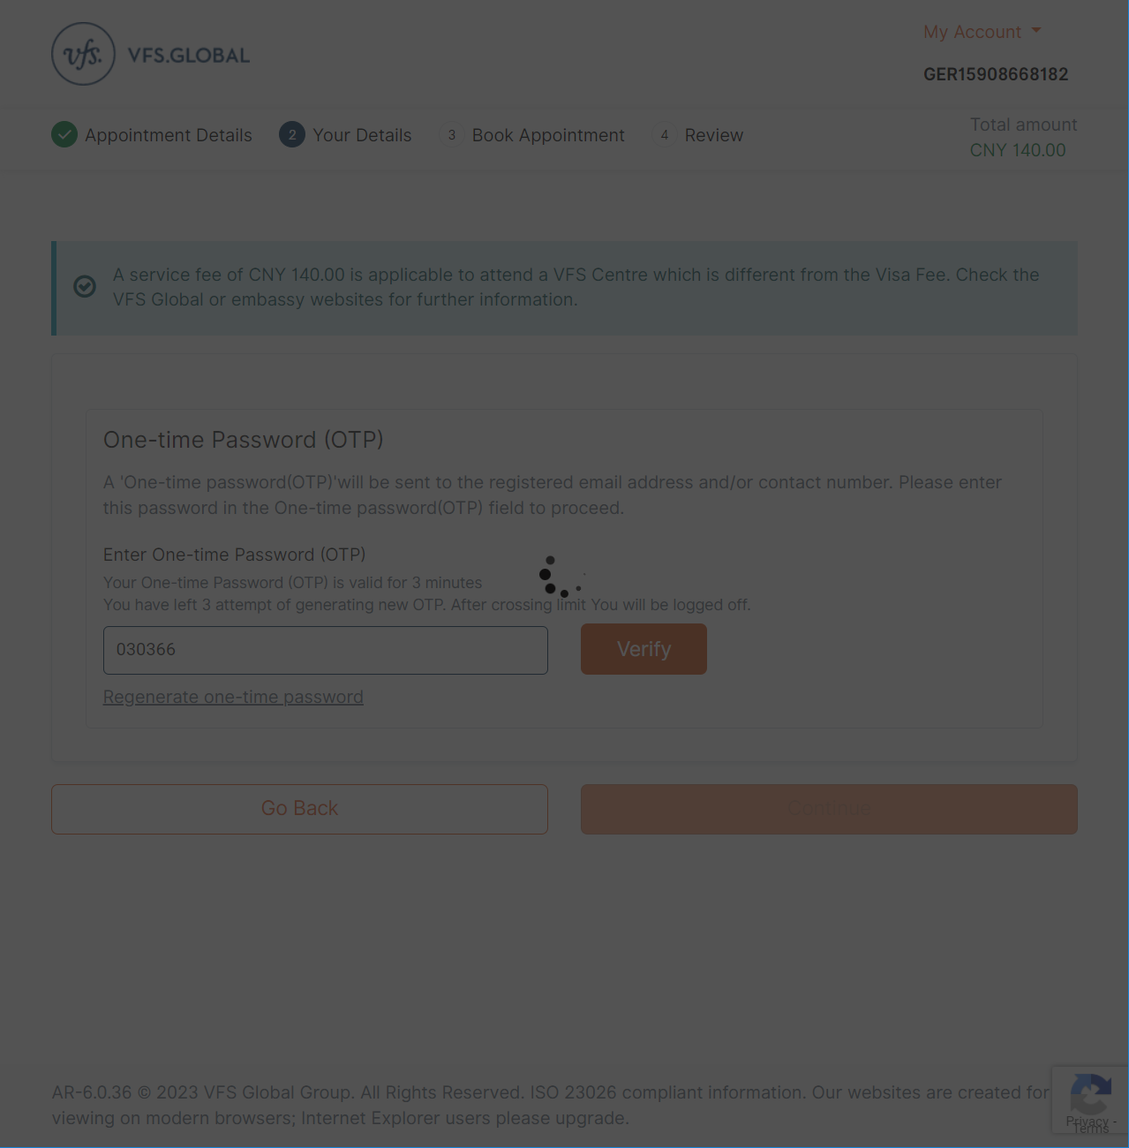

1. Book appointment page

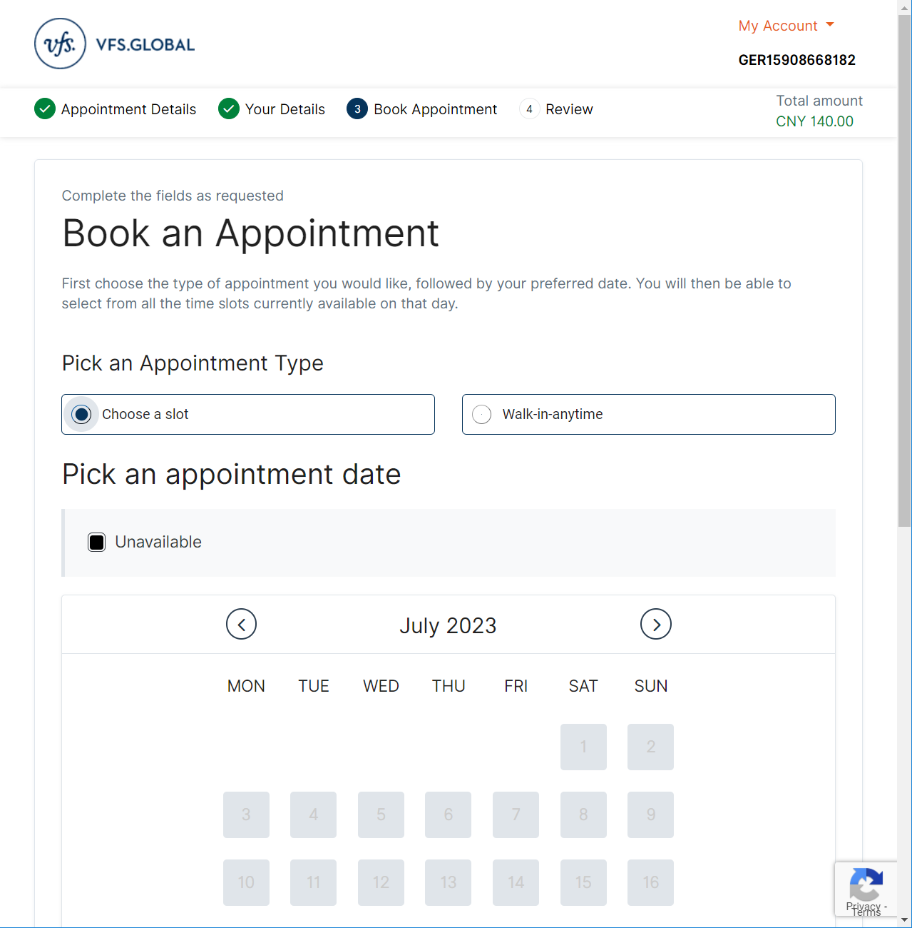

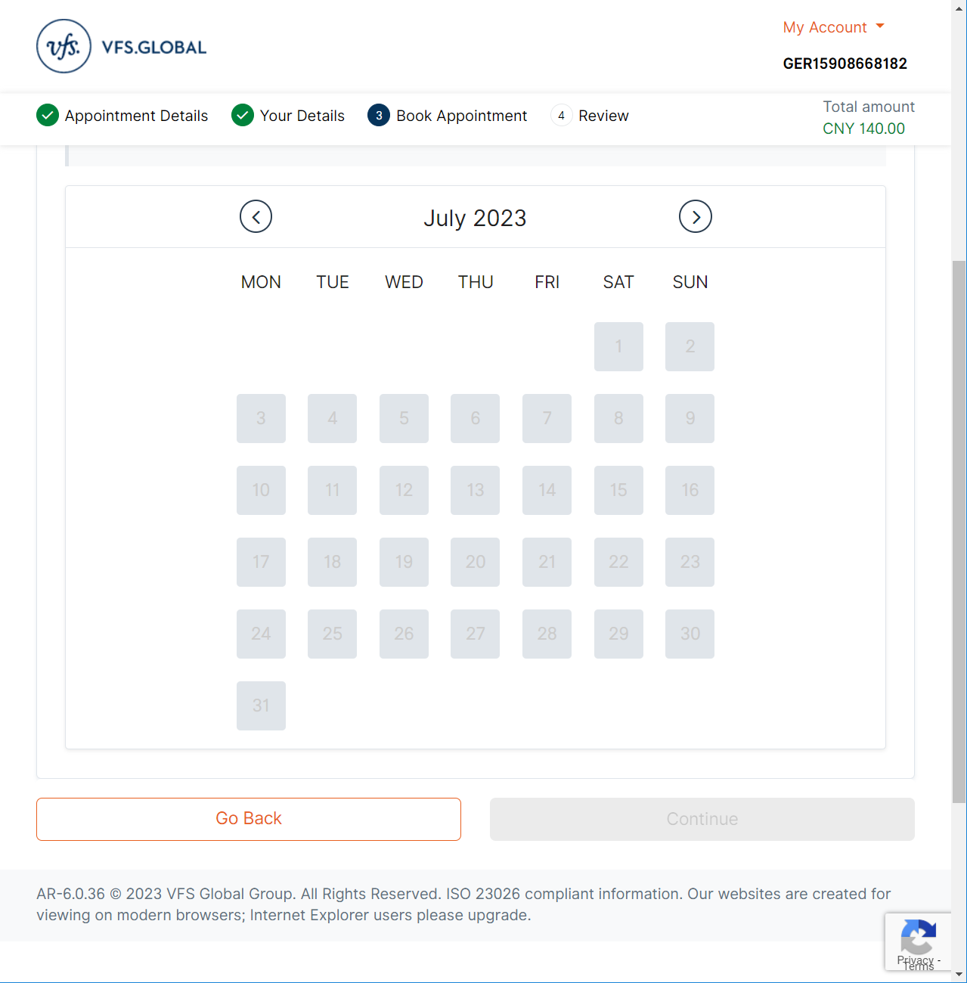

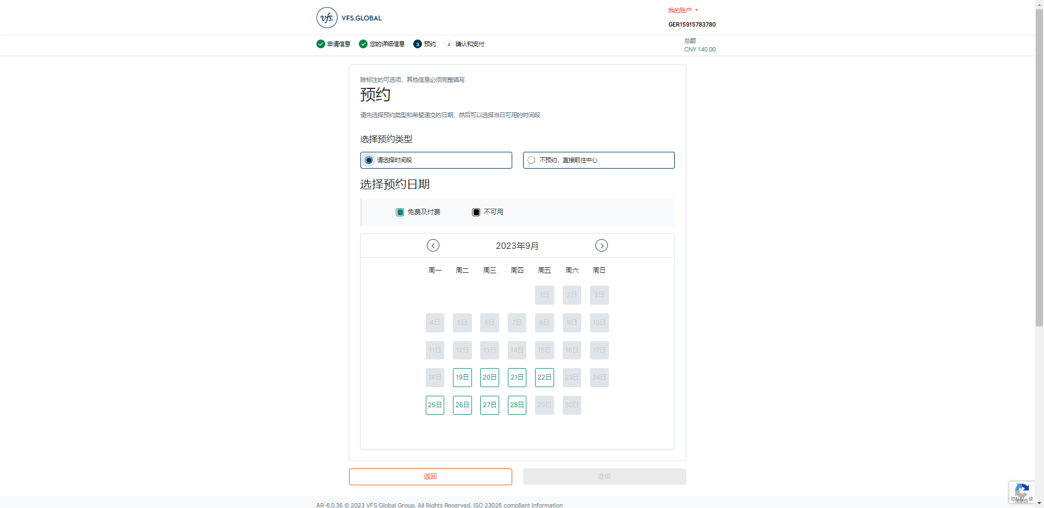

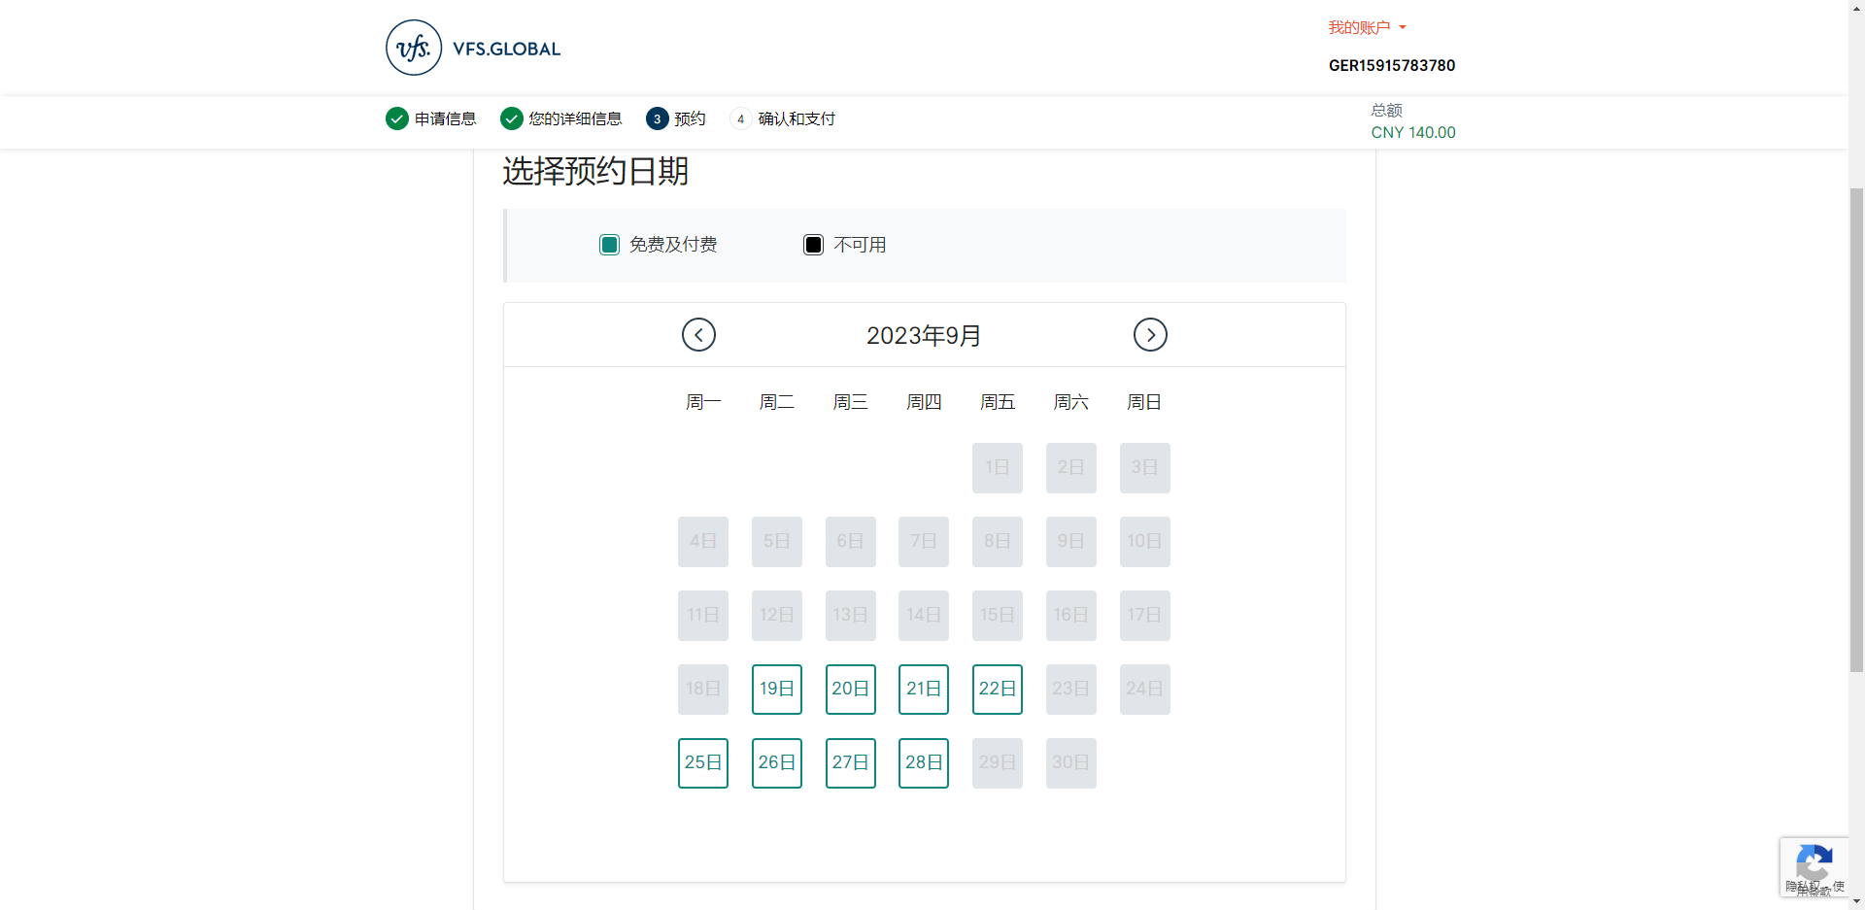

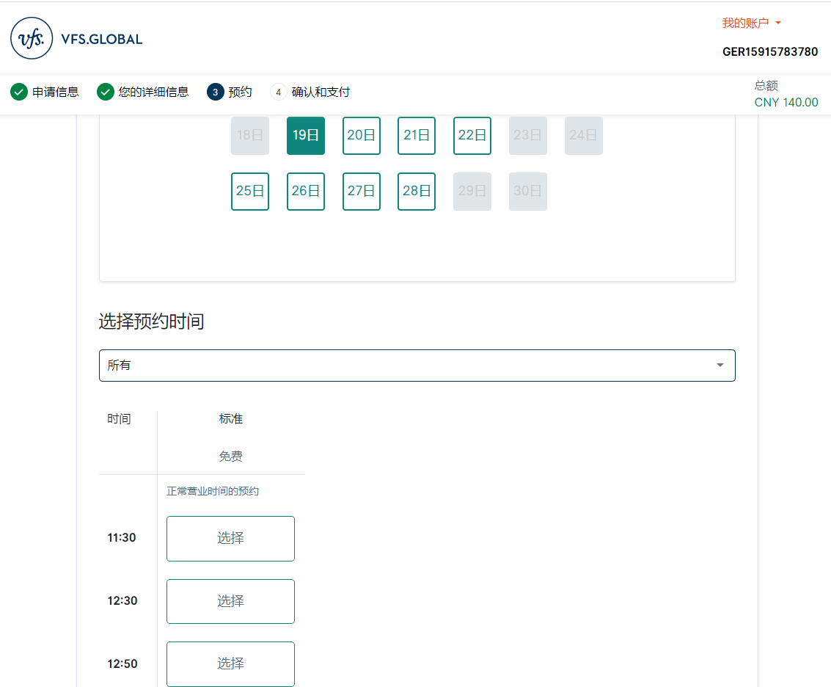

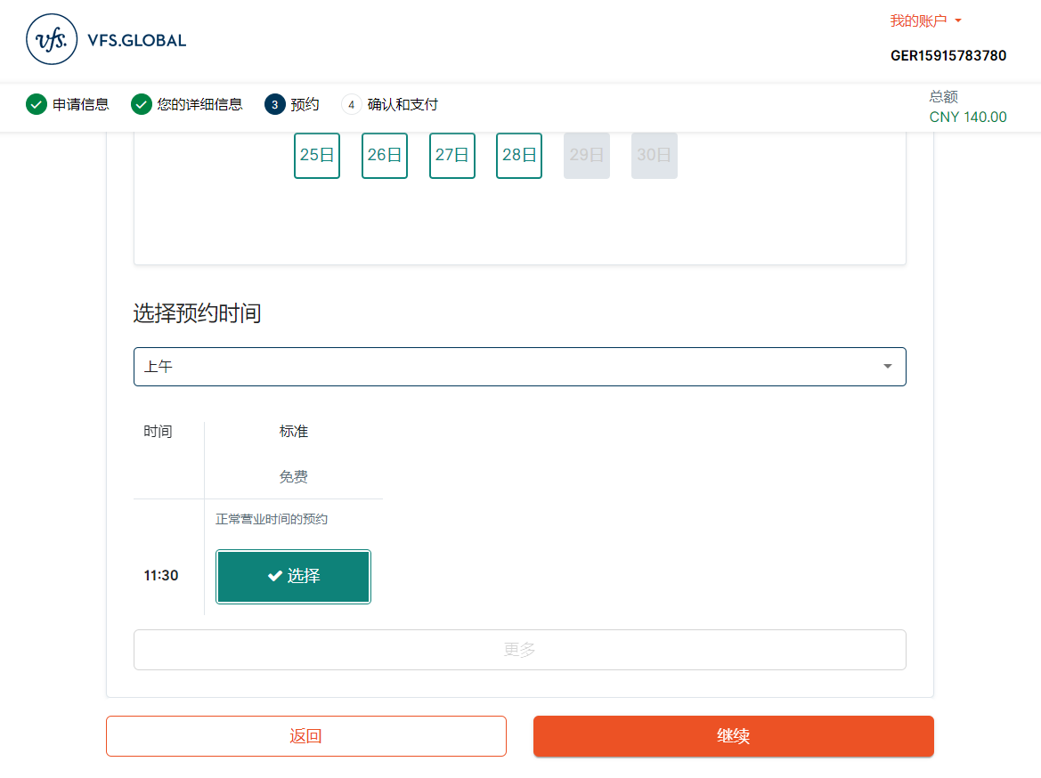

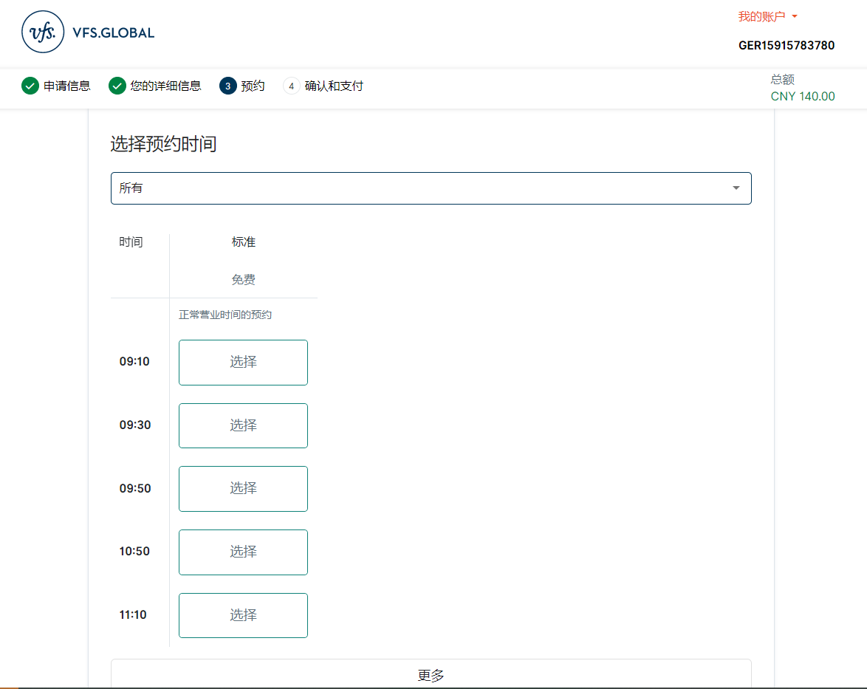

1. Services page

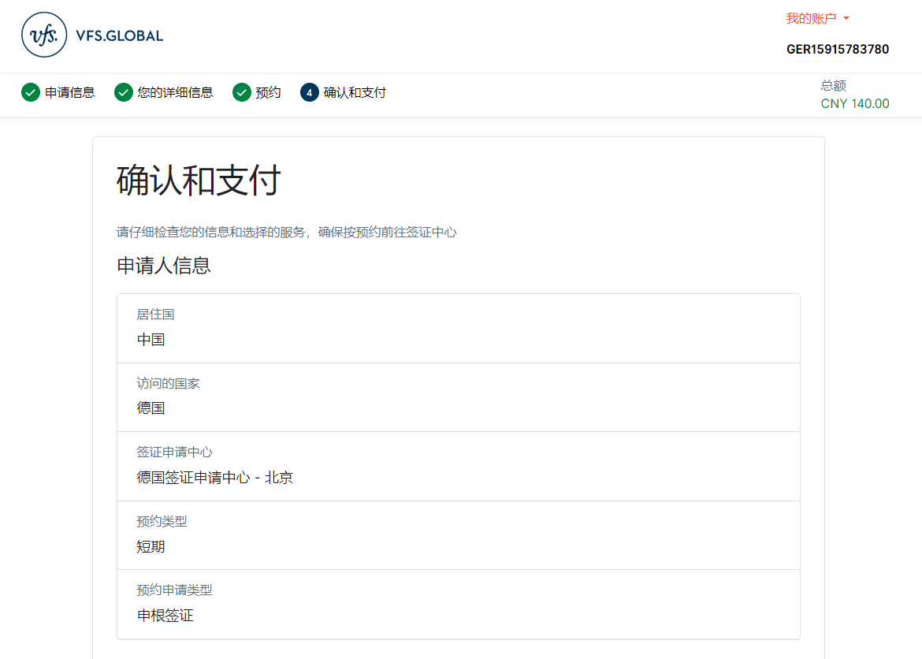

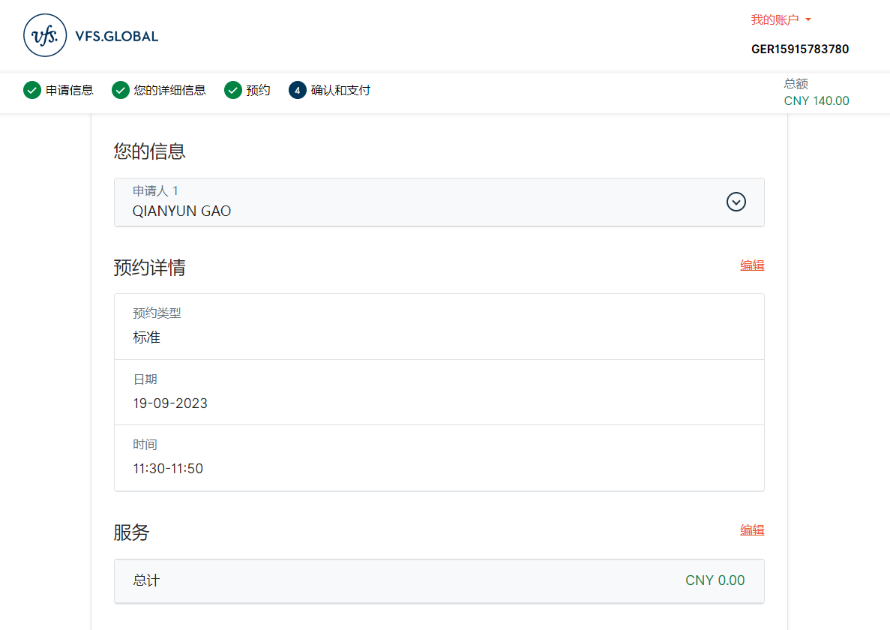

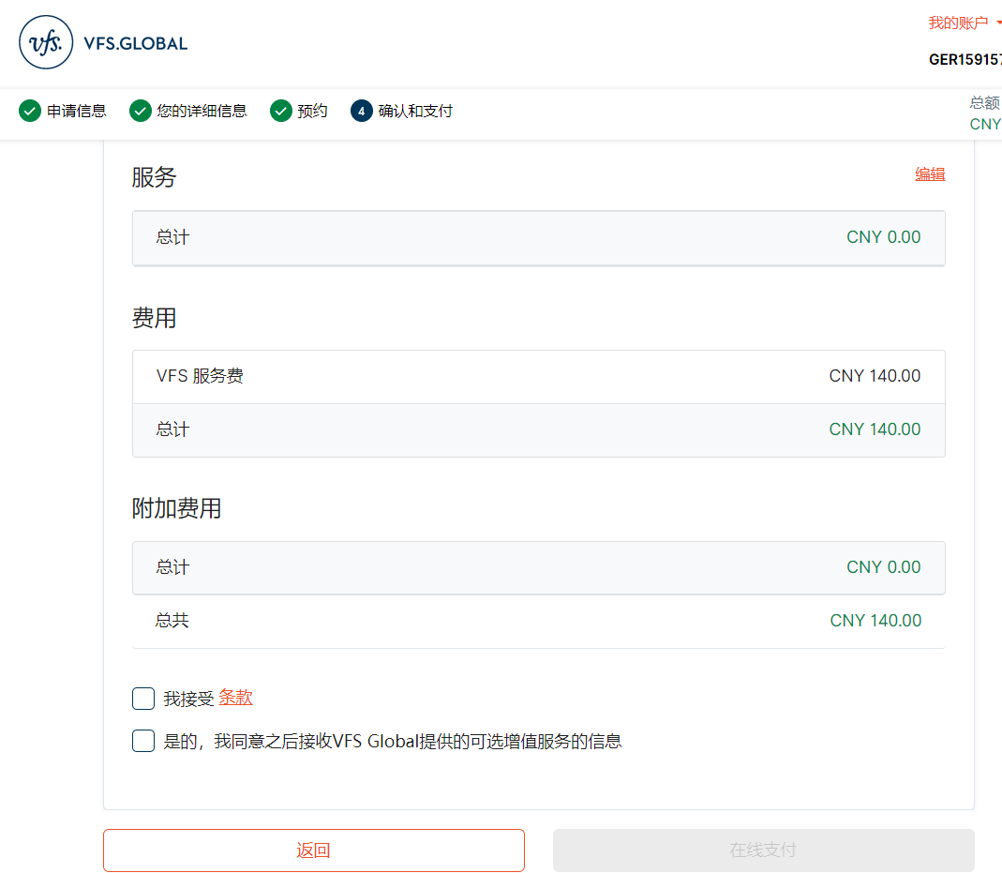

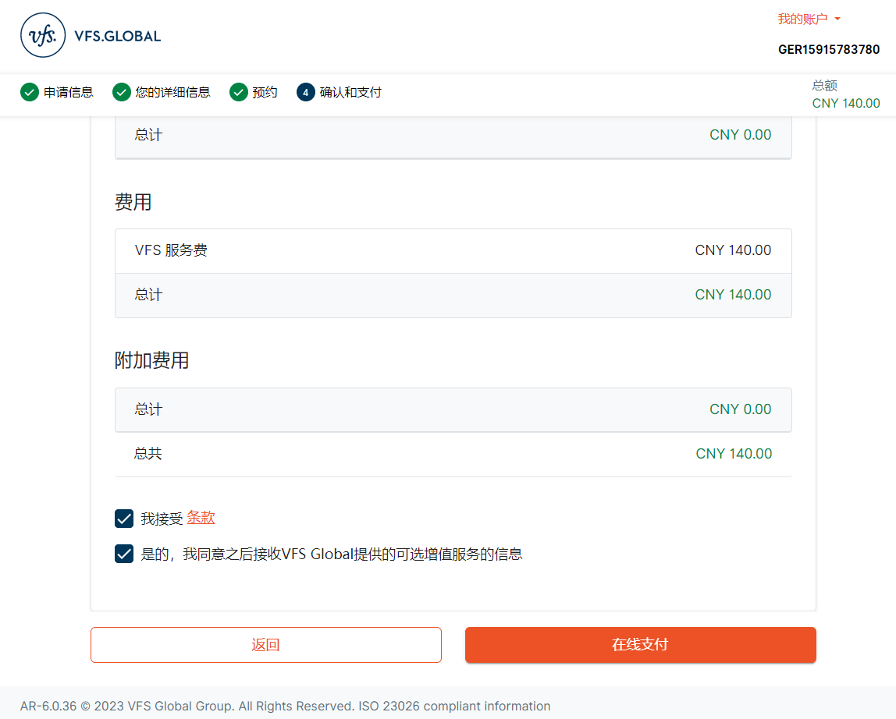

1. Review page

Todo: not sure what this page do Need inputs